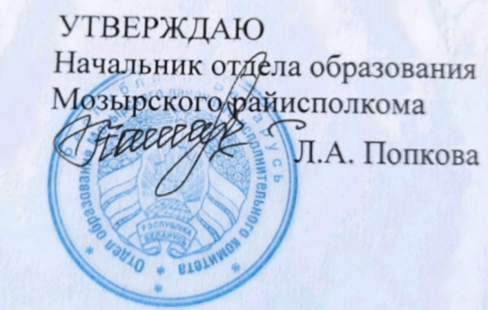
19.10.2022

Задания первого этапа республиканской олимпиады
по учебному предмету «Английский язык»
2022/2023 учебный год
X класс

Аудирование

You will hear a man called Markus Fischer talking about mooncake, a traditional Asian bakery product. For questions 1 - 10, complete the sentences with a word or short phrase relevant to the audio. (10 points)

Mooncake
Markus was staying in (1) ____________ when he first tried mooncake.
Markus's favourite kind of mooncake has a filling made of (2) _____________.
Markus says that he likes to have (3) _______________with mooncake. Mooncake is popular during the Moon Festival, which last year was held in (4) __________. The mooncake Marcus was given during the festival had the shape of a (5) _____________ on the top.
Markus was surprised to learn that mooncake is rarely made (6) ___________ in China.
The people Markus was staying with received mooncake from their (7) ____________.
His host family gave Markus a mooncake that had a slightly (8) __________ flavour.
Markus was told that, many years ago, people used mooncakes to send (9) _________ to each other.
After people had read what was written on the mooncake, they (10) __________ it.

